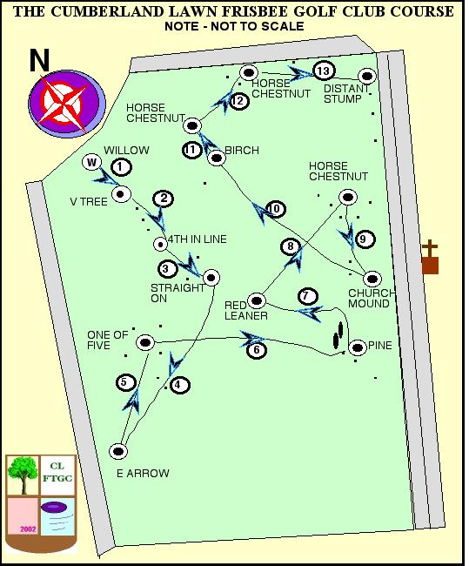
THE CUMBERLAND LAWN FRISBEE TREE GOLF CLUB,
REGENTS PARK LONDON.

Hole | From / to (par)

1 | Willow to V tree (4)
2 | V tree to 4th in line (4)
3 | 4th in line to straight on (3)
4 | Straight on to E arrow (5)
5 | E arrow to one of five (4)
6 | One of five to pine hidden by holly (5)
7 | Pine to Red leaner (4)
8 | Red leaner to Big HC (4)
9 | Big HC to church mound (3)
10 | Church mound to Birch on hill (5)
11 | Birch to Horse Chestnut (2)
12 | Horse to Horse (3)
13 | HC to stump (5)

